Practical – 2
Study of pre-processing methods:-
Write a program to find following statistics from a given dataset.
Mean, mode, median, variance, Remarks standard deviation, quartiles, interquartile range.
- Program to find mean, mode, median, variance, and standard deviation of given dataset:

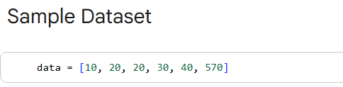

- Mean:- The mean is the average value of a dataset. It is calculated by adding all observations and dividing by the total number of observations. It represents the central tendency of the data.
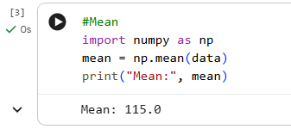

- Median:- The median is the middle value of a dataset when the data is arranged in ascending order. If the number of observations is even, the median is the average of the two middle values.
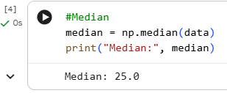

- Mode:- The mode is the value that occurs most frequently in a dataset. A dataset can have one mode, more than one mode, or no mode at all.
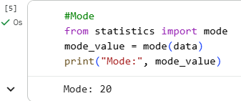

- Variance:- The variance measures how much the data values are spread out from the mean. A higher variance indicates greater dispersion in the data.
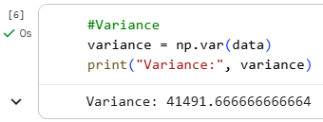

- Standard Deviation:- The standard deviation is the square root of the variance. It shows how much the data values typically deviate from the mean and is expressed in the same units as the data.
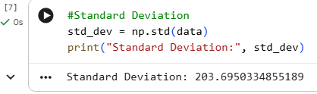

- Quartiles:- Quartiles divide a sorted dataset into four equal parts:
- Q1 (First Quartile): 25% of data lies below this value
- Q2 (Second Quartile): 50% of data lies below this value (Median)
- Q3 (Third Quartile): 75% of data lies below this value
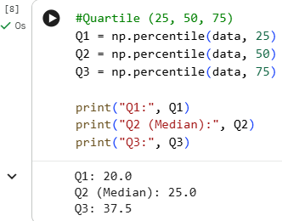
- Interquartile Range(IQR):- The interquartile range is the difference between the third quartile (Q3) and the first quartile (Q1). It measures the spread of the middle 50% of the data and helps in detecting outliers.
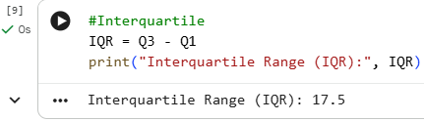

- Handling Missing Values With Mean, Median, and Mode:
Handling missing values is an important step in data preprocessing to ensure data quality and reliable model performance.
- Mean Imputation:
Missing values are replaced with the mean of the column. This method is suitable for numerical data with no extreme outliers, as the mean represents the average value.
- Median Imputation:
Missing values are replaced with the median of the column. This method is preferred when the data contains outliers or skewed distributions, since the median is less affected by extreme values.
- Mode Imputation:
Missing values are replaced with the mode (most frequent value) of the column. This method is commonly used for categorical data, where numerical averages are not meaningful.

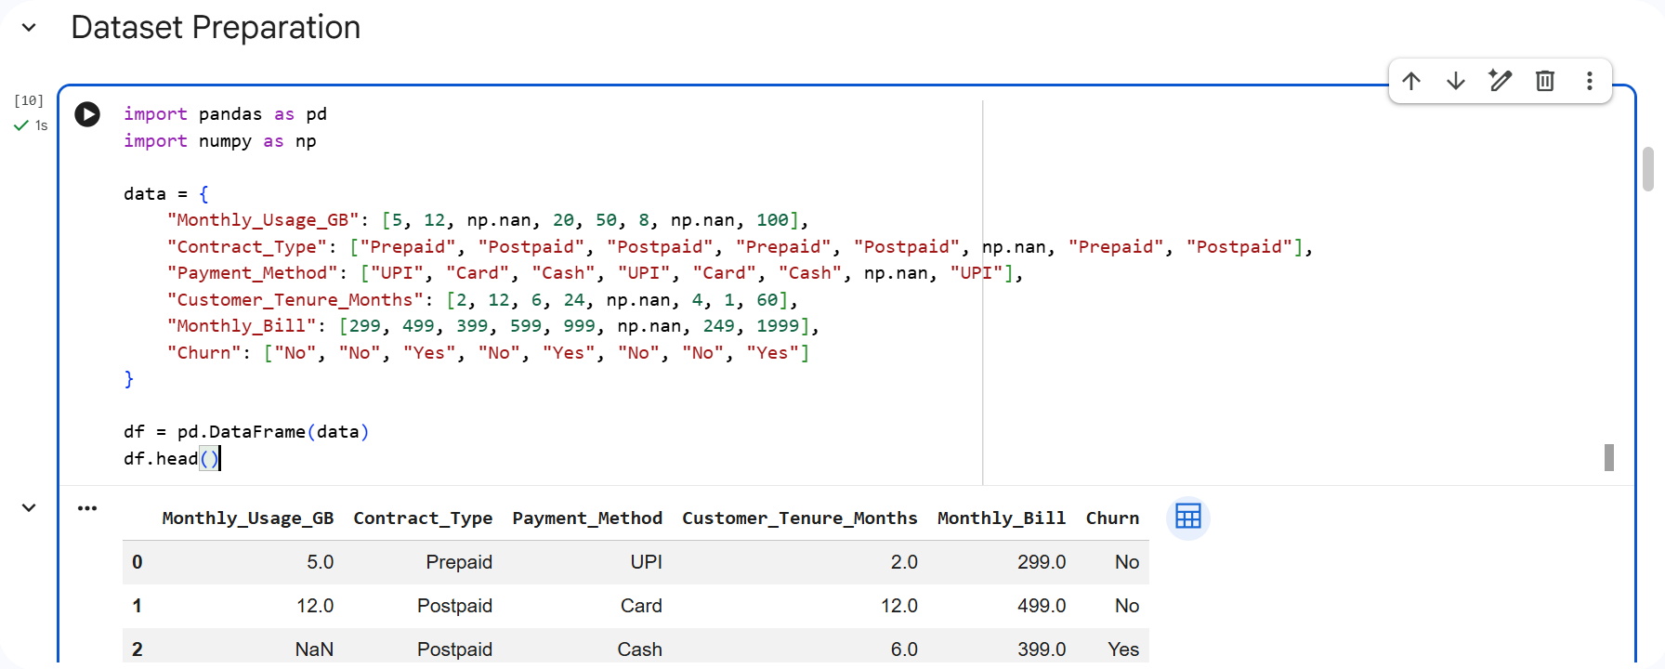
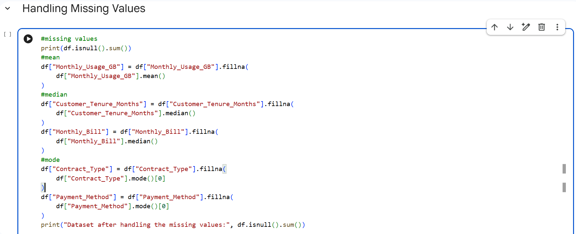
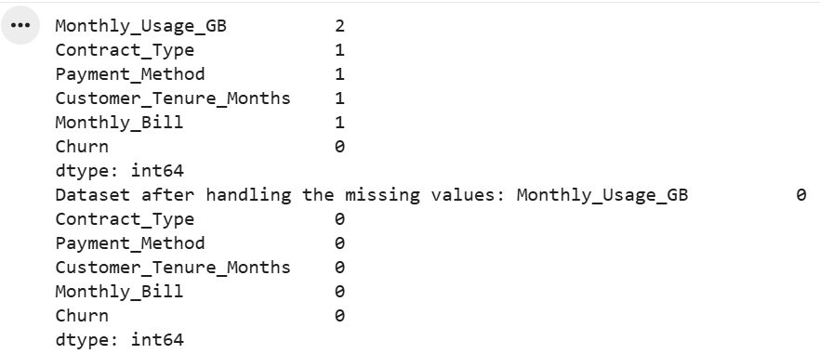

- One-Hot Encoding:
One-hot encoding is a technique used to convert categorical variables into numerical format by creating separate binary columns for each unique category. Each column represents one category and contains values of 1 (present) or 0 (absent).
This method prevents the model from assuming any ordinal relationship between categories, making it especially suitable for nominal categorical data such as colors, cities, or types. However, one-hot encoding can increase the number of features when a column has many unique values.
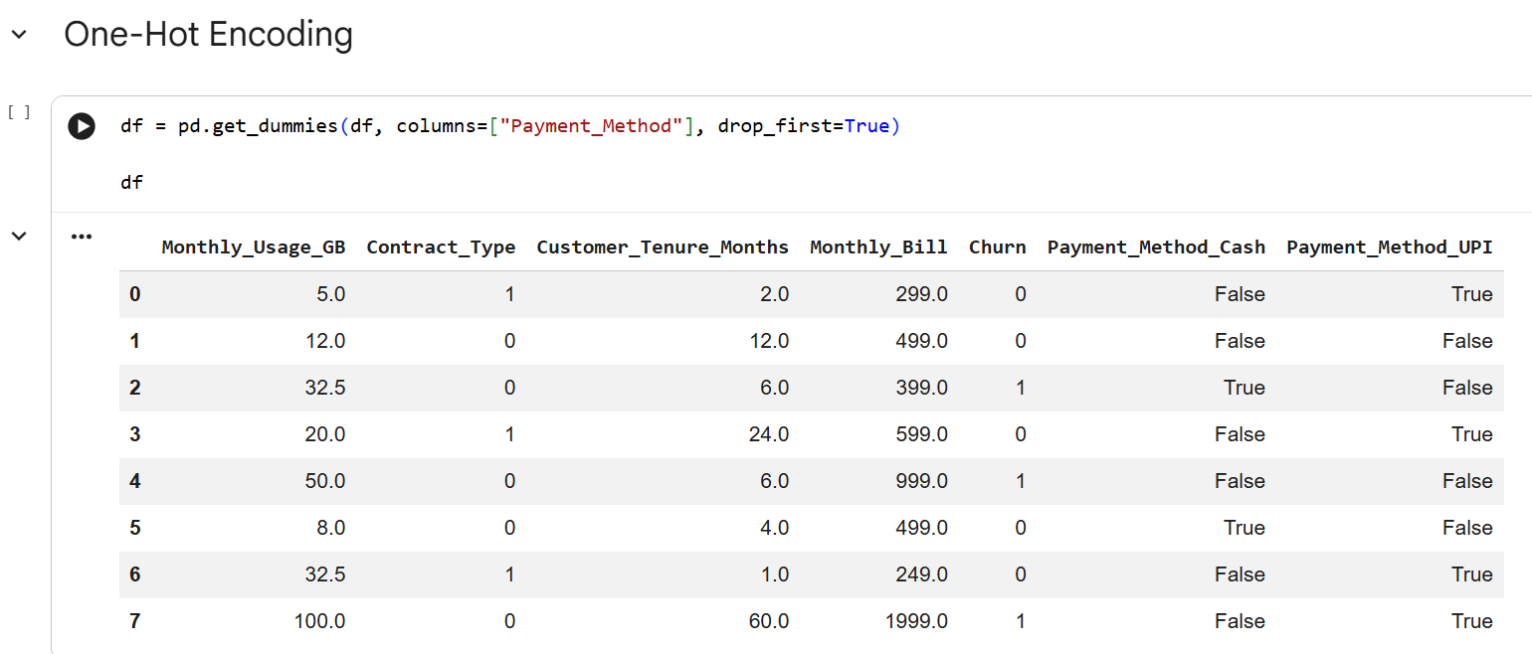
- Label Encoding:
Label encoding is a data preprocessing technique used to convert categorical values into numerical form. Each unique category in a column is assigned a unique integer value. This allows machine learning algorithms to work with categorical data.
Label encoding is mainly used for ordinal categorical data, where the categories have a meaningful order (e.g., Low, Medium, High). For nominal data with no inherent order, label encoding may introduce unintended relationships.
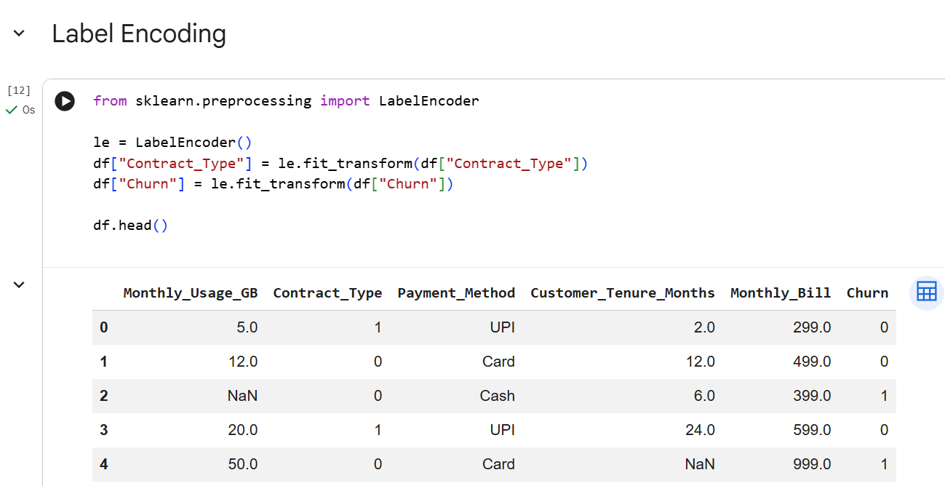
- Interquartile Range(IQR):
The Interquartile Range (IQR) is a statistical measure used to describe the spread of the middle 50% of a dataset. It is calculated as the difference between the third quartile (Q3) and the first quartile (Q1).
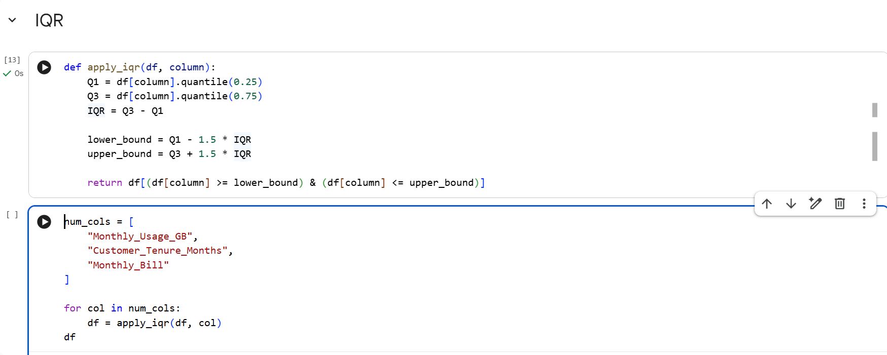
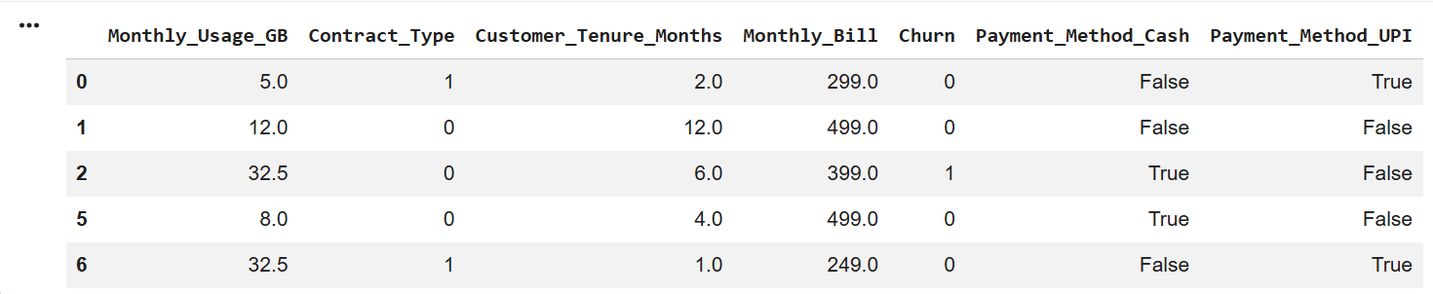
- Normalization:

Normalization is a data preprocessing technique used to scale numerical features to a common range, usually between 0 and 1. It ensures that all features contribute equally to the model and prevents features with larger values from dominating those with smaller values.

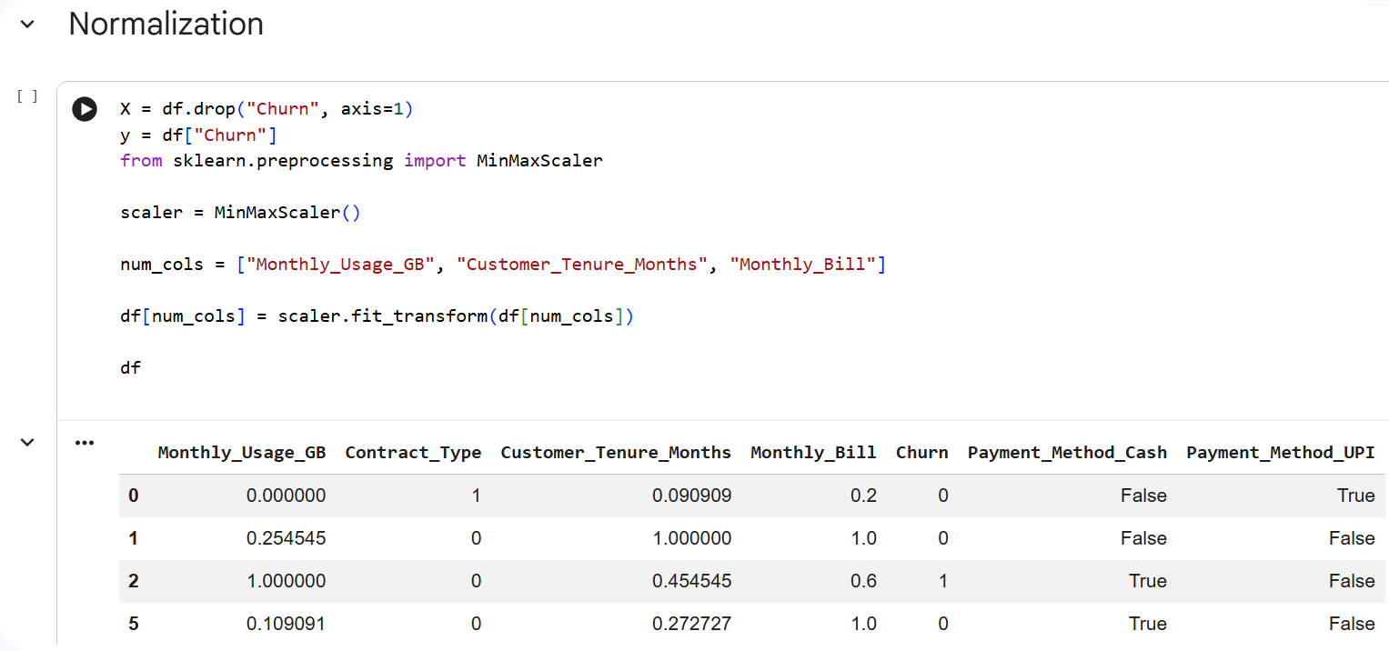
- Regularization (Lasso):
Lasso regularization is a technique used to prevent overfitting by adding a penalty equal to the absolute values of model coefficients to the loss function. This penalty discourages large coefficients and can shrink some coefficients exactly to zero.
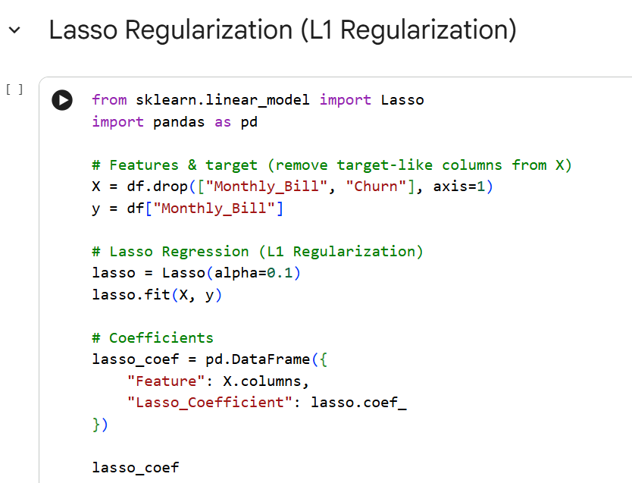
Because of this property, Lasso not only reduces model complexity but also performs feature selection by eliminating less important features. Lasso regularization is widely used in linear and logistic regression models, especially when dealing with high-dimensional data.

